

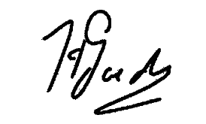

PROOF OF REGISTRATION 2026
It is hereby certified that

Caleb, Ruben Vincent
(Date of birth: 13/11/2003) (Student Number: 42849349 - 2026)

is registered as a student on the Potchefstroom Campus (NWU Faculty of Natural and Agricultural Sciences)

for

Bachelor Of Science With Computer Science And Mathematics
(2FF-H09-N301P-FT)
Contact 20/01/2025
Year Level 2
Courses : Course: H = core course; X = non-core course; A = additional course

CMPG211 | Object Oriented Programming | 2026SEM1 | H
STTN215 | Probability And Sampling Theory | 2026SEM1 | X
MTHS211 | Advanced Calculus 1 | 2026SEM1 | H
MTHS212 | Linear Algebra 1 | 2026SEM2 | H
WVNS211 | Understanding The Natural World | 2026SEM2 | H
CMPG221 | Data Structures And Algorithms | 2026SEM2 | H
CMPG222 | Data Analytics 2 | 2026SEM2 | X

Registration date: 27/02/2026 Date of issue: 27/02/2026

REGISTRAR

27/02/2026
Web: https://www.nwu.ac.za

